

Under the Guidance of
Mr. Ashish Shivhare
Java trainer

SESSION: 2025-26

Submitted By
Shradha Mishra
Erp No - 11253

RUNGTA INTERNATIONAL SKILLS
UNIVERSITY
BHILAI ,
CG
File Compression Simulator

(
Using Core Java & OOP Concepts
)
RU-100-01-00012

Object Oriented Programming With Java
Project Interim Report

On
Bachelor of Technology in Computer Science &
Engineering with AI and ML in association with IBM
SCHOOL OF COMPUTER SCIENCE AND E
NGINEERING

(
April
2026)
Abstract
The Employee Payroll Management System is a Java-based application designed to automate salary calculation for employees. The system uses object-oriented programming principles such as inheritance, polymorphism, constructor chaining, and method overriding. It introduces a parent Employee class and specialized subclasses like FullTimeEmployee and PartTimeEmployee, each with its own salary calculation logic.
This project eliminates manual payroll calculations and ensures accuracy, efficiency, and flexibility in managing employee salaries. The system allows creation of employee objects, calculates salaries based on employee type, and displays structured output. The project provides a practical implementation of OOP concepts and can be extended to include more employee categories and features.

Introduction
Payroll management is a critical task in any organization. Manual payroll processing can be time-consuming and prone to errors. This project provides a simplified and automated solution using Java and OOP concepts.
The Employee Payroll Management System handles employee data and salary computation using inheritance and polymorphism. It includes a parent Employee class that defines common properties such as name, ID, and base salary. Specialized classes like FullTimeEmployee and PartTimeEmployee extend the base class and implement specific salary calculations.

Key Features:
- Efficient salary calculation
- Modular class design
- Demonstrates real-world OOP implementation
- Uses inheritance and polymorphism
- Easy to extend with new employee types

Objectives
- To design an employee management system using inheritance and polymorphism
- To calculate salary for different employee types
- To implement constructor chaining using the super keyword
- To demonstrate dynamic method binding
- To improve modularity and reusability of code

Scope
This project is suitable for small organizations to automate salary calculation. It can be extended in the future with:
- Database integration
- GUI-based interface
- Attendance and leave tracking
- Employee login systems
- Payroll report generation

System Requirements

Hardware Requirements
- Minimum 4 GB RAM
- Any modern CPU

Software Requirements
- Java JDK
- IDE (VS Code / Eclipse / IntelliJ / Edit Plus)
Methodology
- Define a base class Employee with common attributes and a salary calculation method.
- Create derived classes FullTimeEmployee and PartTimeEmployee.
- Use constructors and super() for initialization.
- Override calculateSalary() in subclasses.
- Use polymorphism to calculate salary dynamically.
- Create objects in the main class and display salary information.

Flowchart
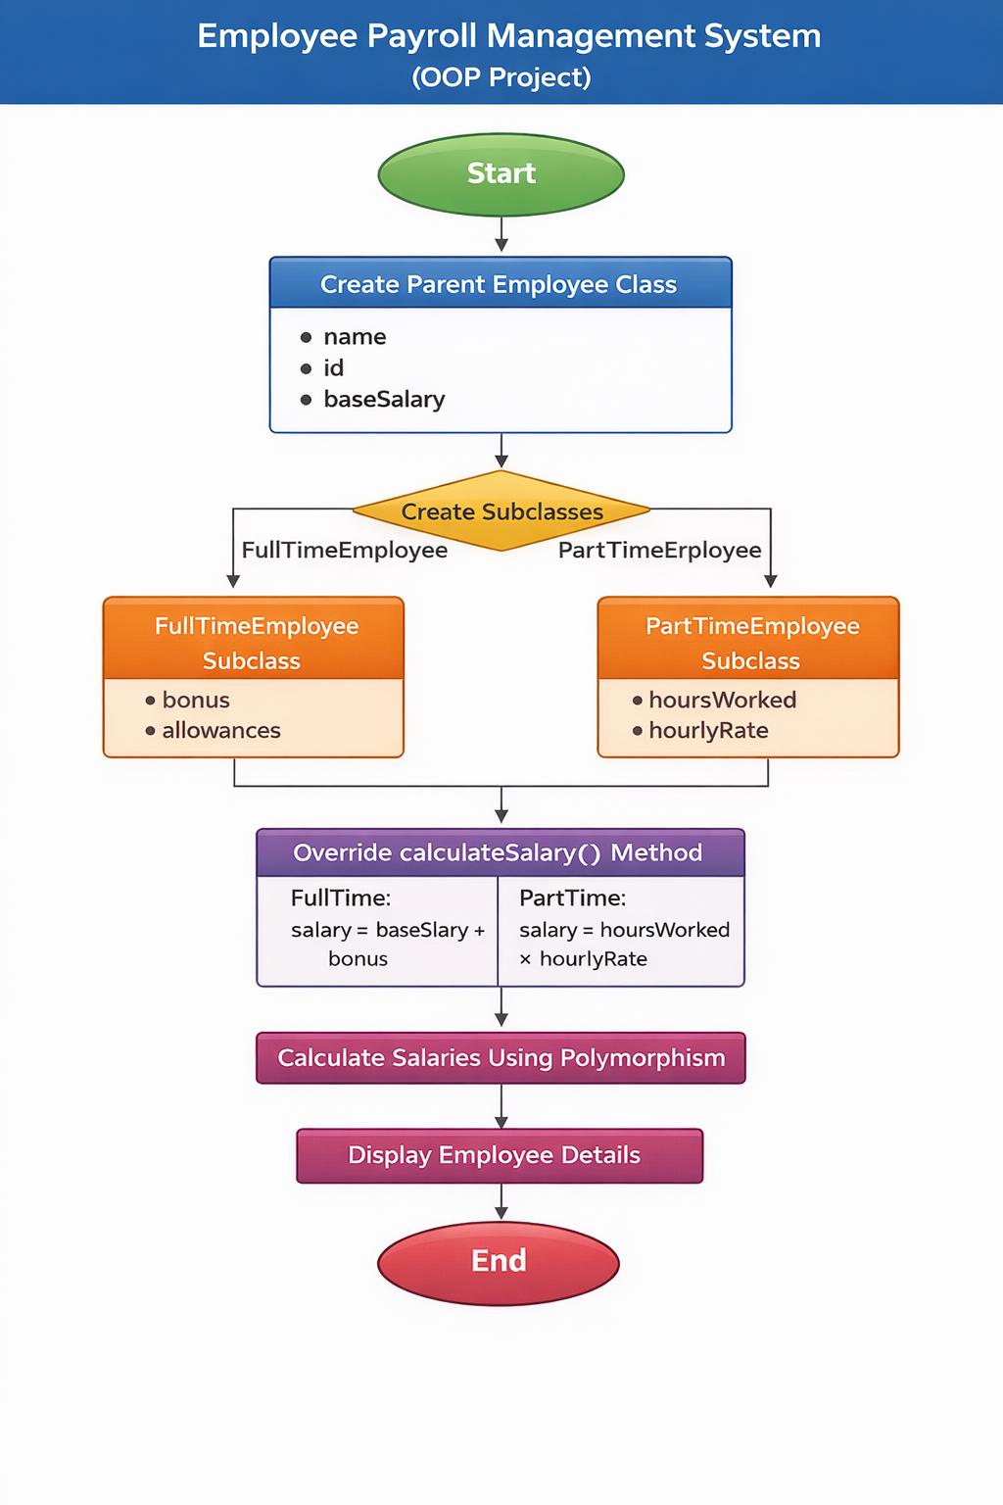
· ClassName
- Variables inside classo Methods inside class
- If array is present within the class also mention it here

Class Diagram (Sample Structure)
Employee
- Variables:
  - name
  - id
  - baseSalary
- Methods:
  - calculateSalary()
FullTimeEmployee
- Variables:
  - bonus
  - allowances
- Methods:
  - calculateSalary() (Overridden)
PartTimeEmployee
- Variables:
  - hoursWorked
  - hourlyRate
- Methods:
  - calculateSalary() (Overridden)

Implementation

Employee Class
Defines common properties like name, ID, and base salary. It contains a method calculateSalary() that is overridden by subclasses.

FullTimeEmployee Class
Extends Employee and adds bonus and allowances. The overridden calculateSalary() method returns base salary plus bonus.

PartTimeEmployee Class
Extends Employee and calculates salary based on hours worked multiplied by hourly rate.

Main Class
Creates employee objects, uses polymorphism, and displays salary details.

Sample Input/Output
Example:
Full Time Employee Salary: 50000
Part Time Employee Salary: 12000
(Attach screenshot of terminal output in your report.)

Future Enhancements
- Integration with database systems
- Graphical user interface
- Attendance and leave management
- Tax and deduction calculations
- Automated payslip generation

Gantt Chart
Conclusion
The Employee Payroll Management System successfully demonstrates the use of object-oriented programming concepts in Java. The system provides a structured approach to handling employee salary calculations while maintaining modularity and scalability. It strengthens the understanding of inheritance, polymorphism, and class hierarchy design.

References

Book
[1] H. Schildt, Java: The Complete Reference, 11th ed. New York: McGraw-Hill, 2018.

Website
[2] Oracle, “Java Documentation,” Oracle. [Online]. Available: https://docs.oracle.com

Conference Paper
[3] S. Kumar, “AI in Education,” in Proc. IEEE Conf. on AI, 2021, pp. 120–125.

Journal Article
[4] A. Sharma and R. Gupta, “Machine Learning Techniques,” International Journal of AI, vol. 5, no. 2, 2020.

